1. Compute a summary on TWcp and TWrat. **Report the minimum, maximum, and**

**mean for each variable**

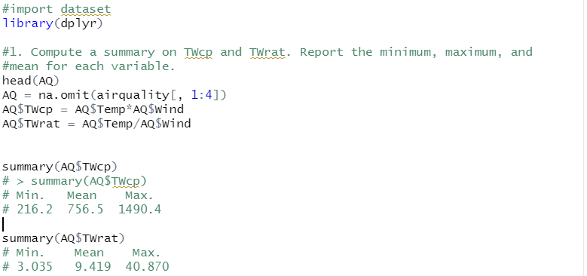

2. Create two new models: Temp + Wind + TWcp and Temp + Wind + TWrat. Fit these

two models in lm().

1. **Report the t-test results for the two new variables**.

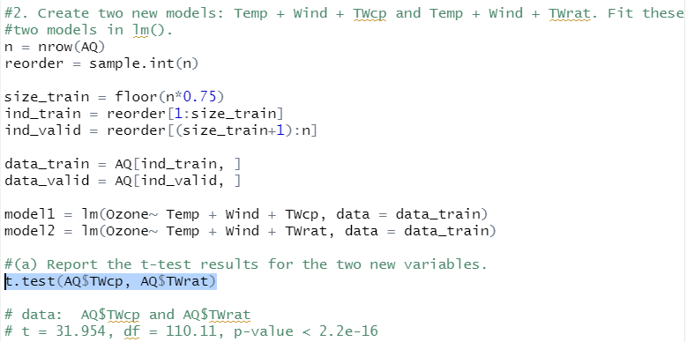

(b) Based on the test results, which variable seems to be the most useful, or are

neither particularly helpful? **(1 sentence)**

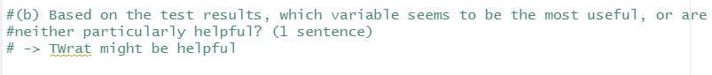

(c) From the model with the cross-product term, compute and **report the slope**

**of the Temp effect when Wind is at its minimum value. Repeat for the**

**maximum value of Wind.** (You can do this by hand from the output if you

want.) 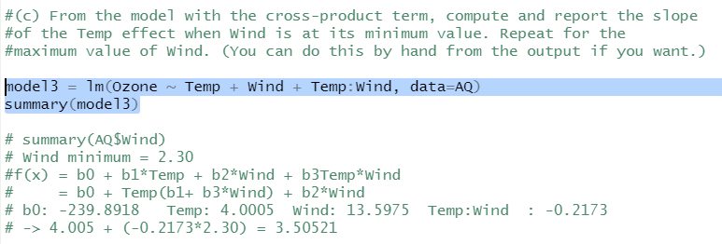

3. Fit each model on the training data and **report the MSPEs from the validation**

**data**.

1. **Which model wins this competition?**
2. 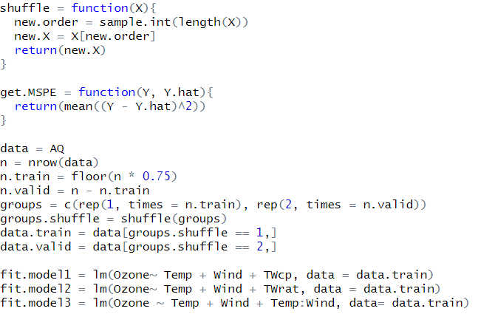
3. 